Andreas Wong Tableau project 1

Question 1: KPI table comparing Profit, Quantity and Sales per region
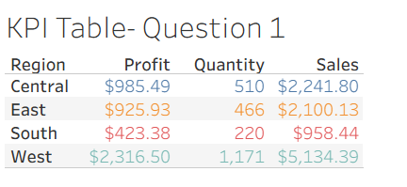
(For this question I assume Markets is actually Region as there is no market column in the data)
Here, we can see that in terms of Sales, the West generates the most Sales/Revenue, Profit, and Order Volume/Quantity. The South is the worst performing region in terms of revenue, profit and order volume.
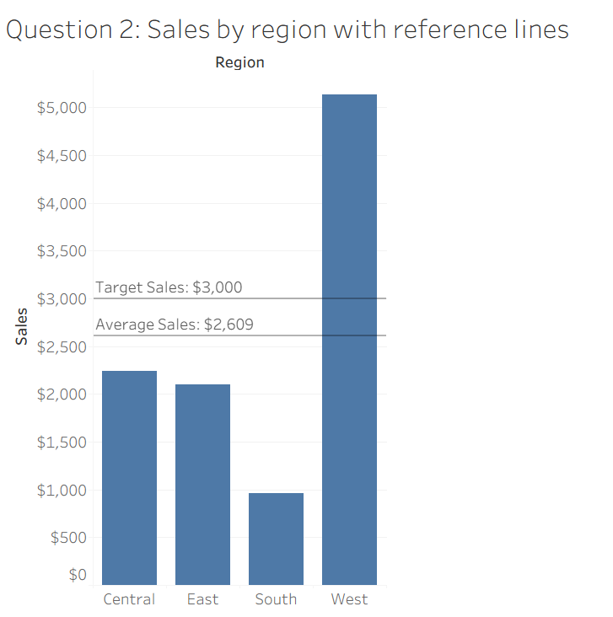
Only the West region is above the Company Average Sales. Central, East and South all underperformed.
In the task there was no Target Sales value mentioned so I just set it to 3000, to which only the West (again) outperformed.

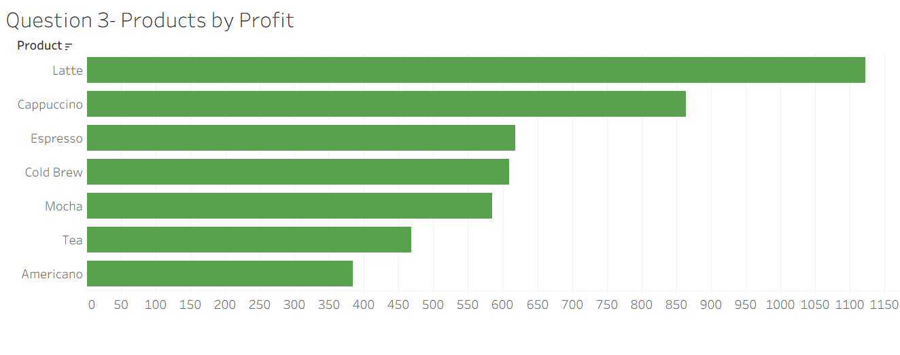
There are only seven products, so it was not possible to show the ‘Top 10’. I will still show all products and order them by profit, as shown above.
However, below, I will show the top three products by profit instead of top 10, done by creating a set called Top 3 Products by Profit.
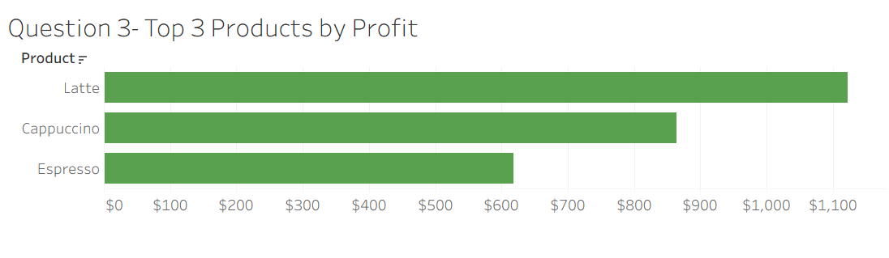

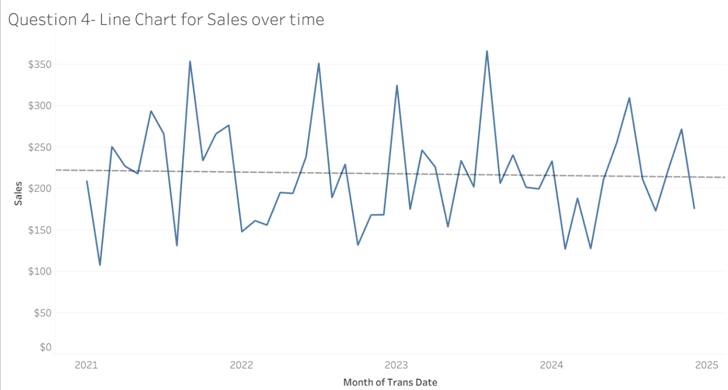
Looking at the trend line, it is basically horizontal, meaning that performance is stable, but the business is not growing. In fact, the trend line has a very small negative co-efficient (-0.0056 4.d.p) which suggests the business is actually declining, although this negative co-efficient is so tiny it doesn’t really mean business is declining.

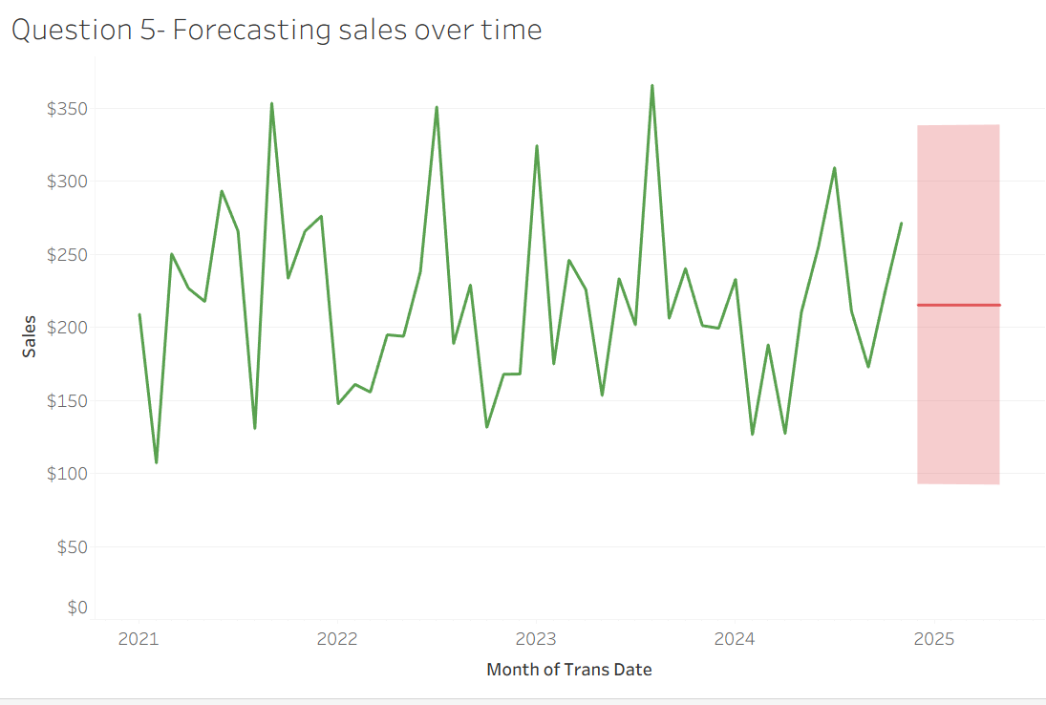
Due to the fact we discovered in the last question that our trend line was basically flat, when asking Tableau to forecast sales for the next six months, it predicted the same sales for each month. However, the 95% confidence intervals show that there is quite a large margin for error in these predictions.
However, this was when I set the forecast model as Automatic. When I set the forecast model to additive, I got these forecasts.
